**Assignment 1**

Name: Ajinkya Gadgil

Student Id: 801200445

**Software Details:**

1. Host Operating System: macOS Monterey 12.3 (M1 Pro Chip)
2. Virtualization tool name and version: UTM

**Part 1:**

VM Installation:

1. I am using a M1 Pro mac chip and virtual box is not supported on M1 mac.
2. There is a VM named UTM that I have used as an alternative.
3. Downloaded UTM from <https://mac.getutm.app>
4. Then downloaded ‘Ubuntu 22.04.1’ from <https://ubuntu.com/download/server/arm>

Below are the steps to run ubuntu image on UTM

1. Download UTM and click in Create a new virtual machine.

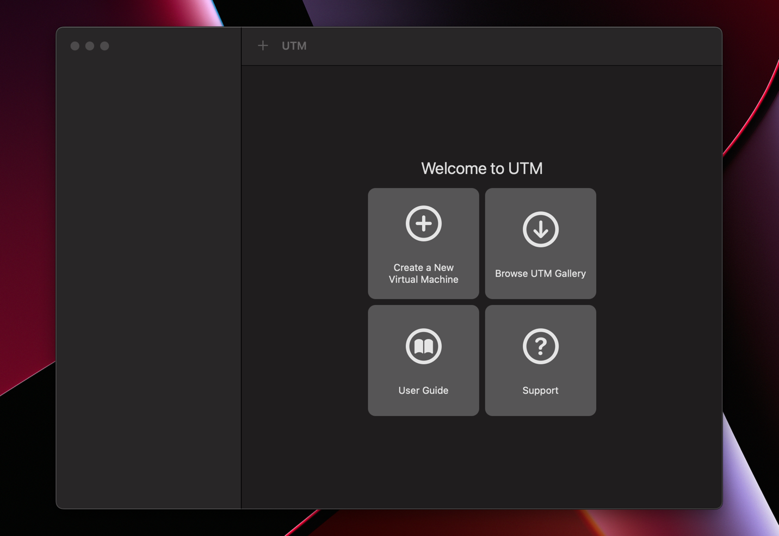

1. Click on virtualize

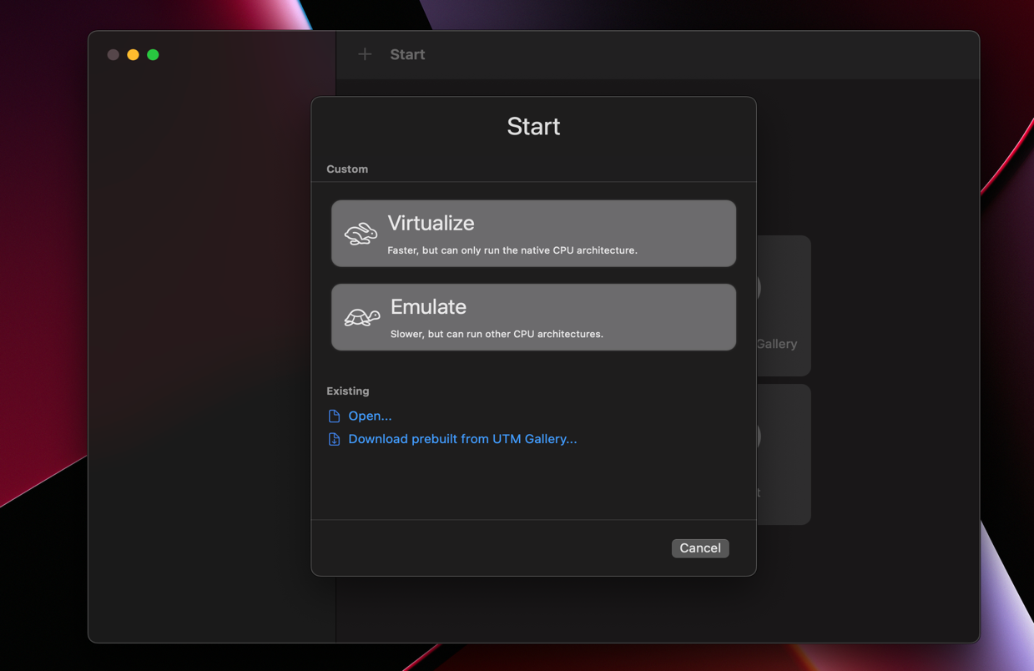

1. Browse the downloaded ubuntu iso image

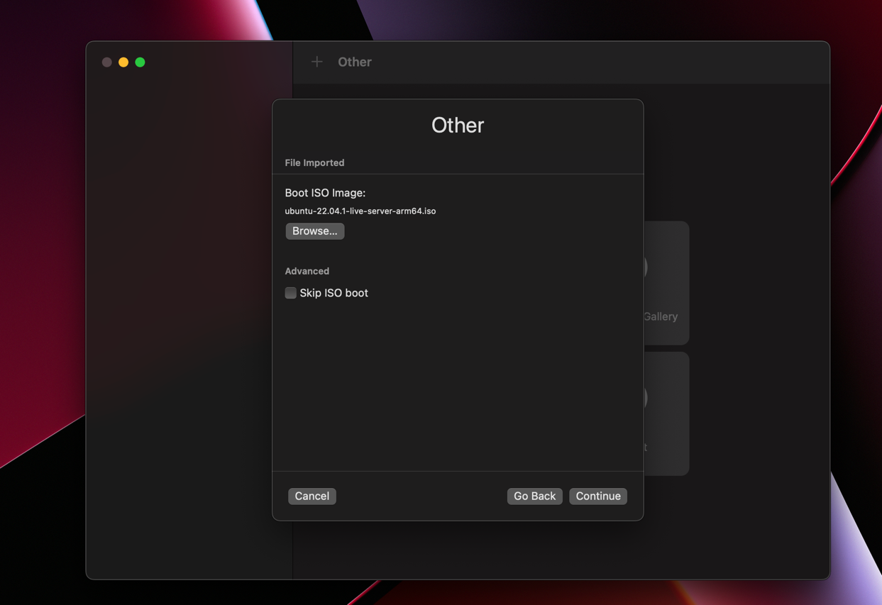

1. Add all configuration and run and click on highlighted option

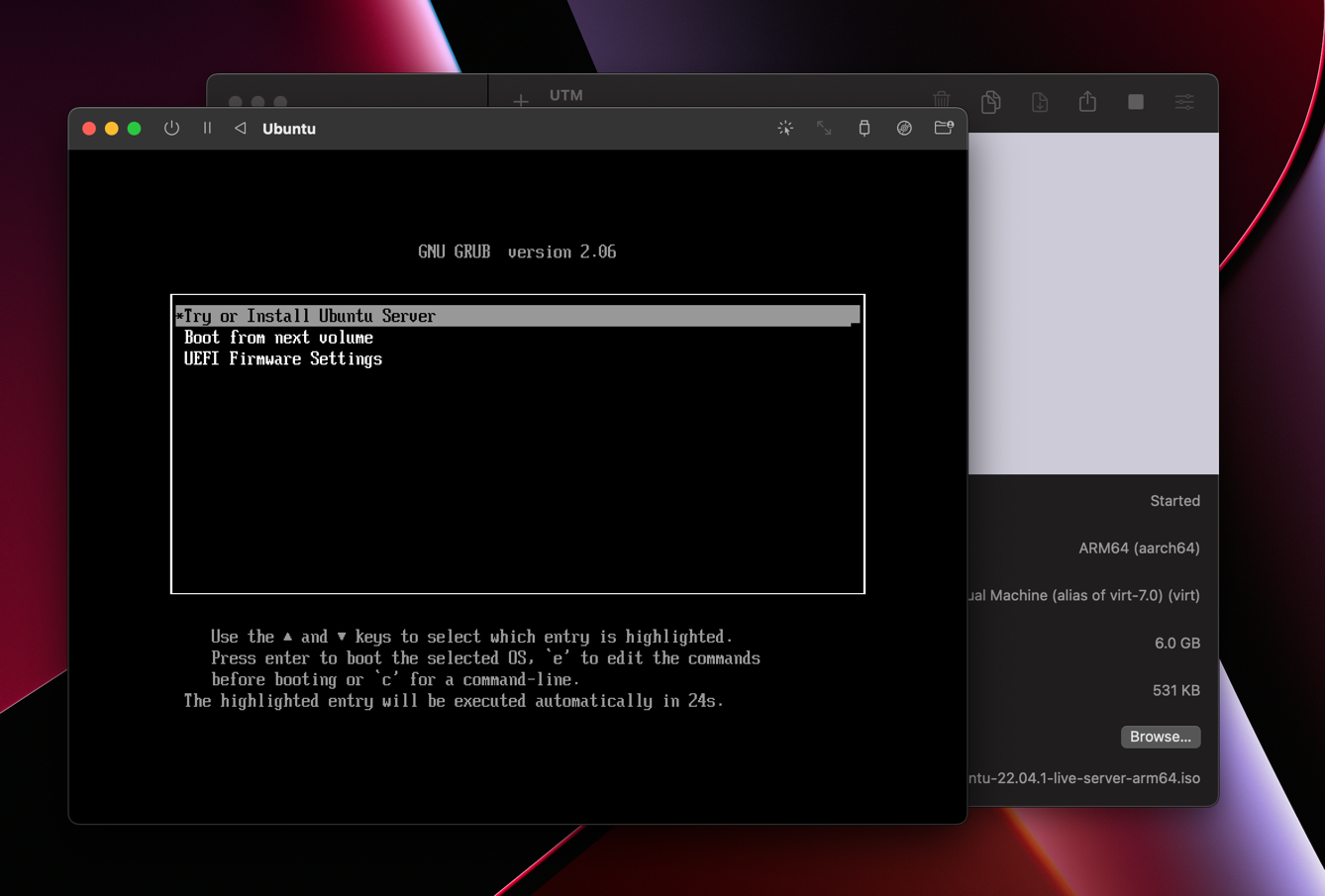

1. After some installation ubuntu command line is displayed.

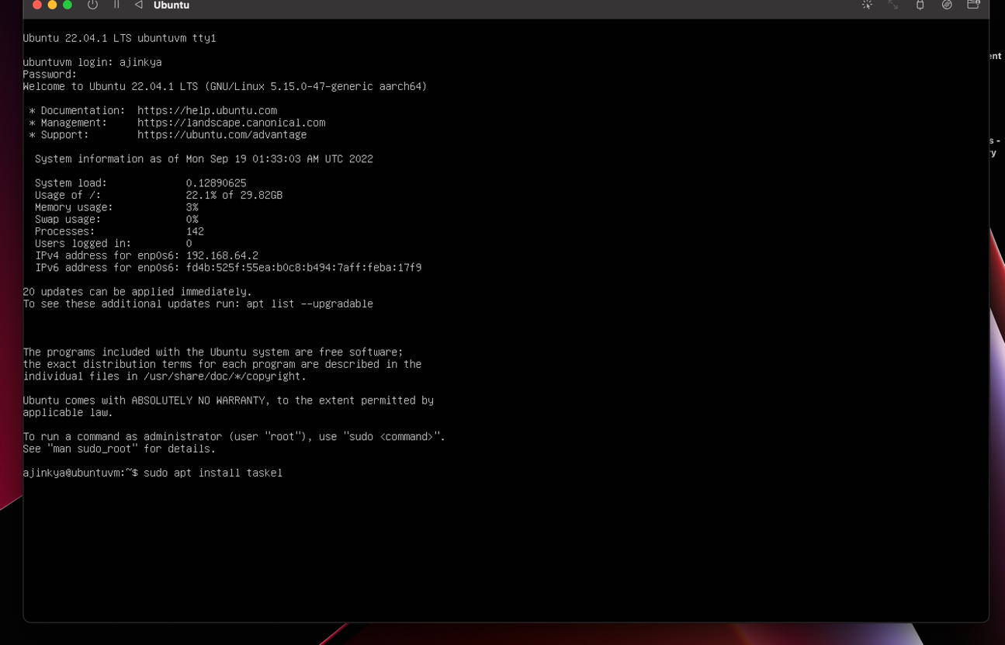

1. After installing ubuntu desktop Ubuntu is running on UTM.

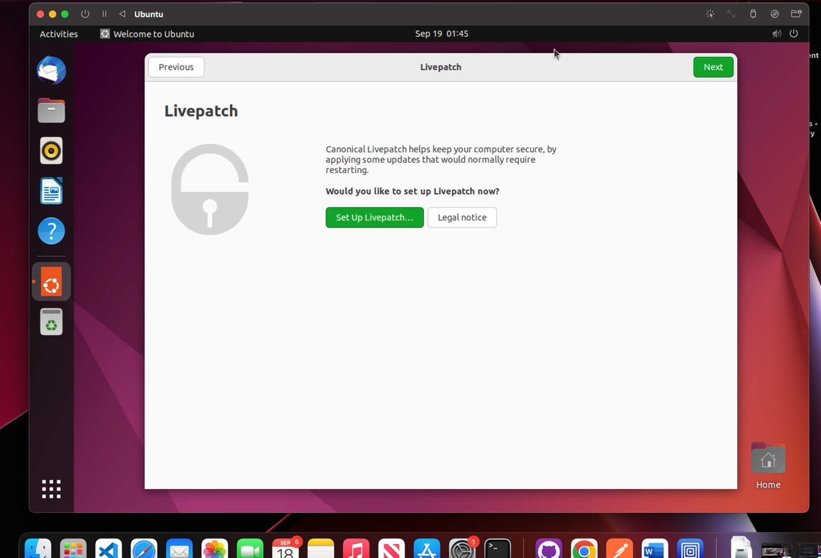

1. Run the Sudo command by opening the terminal

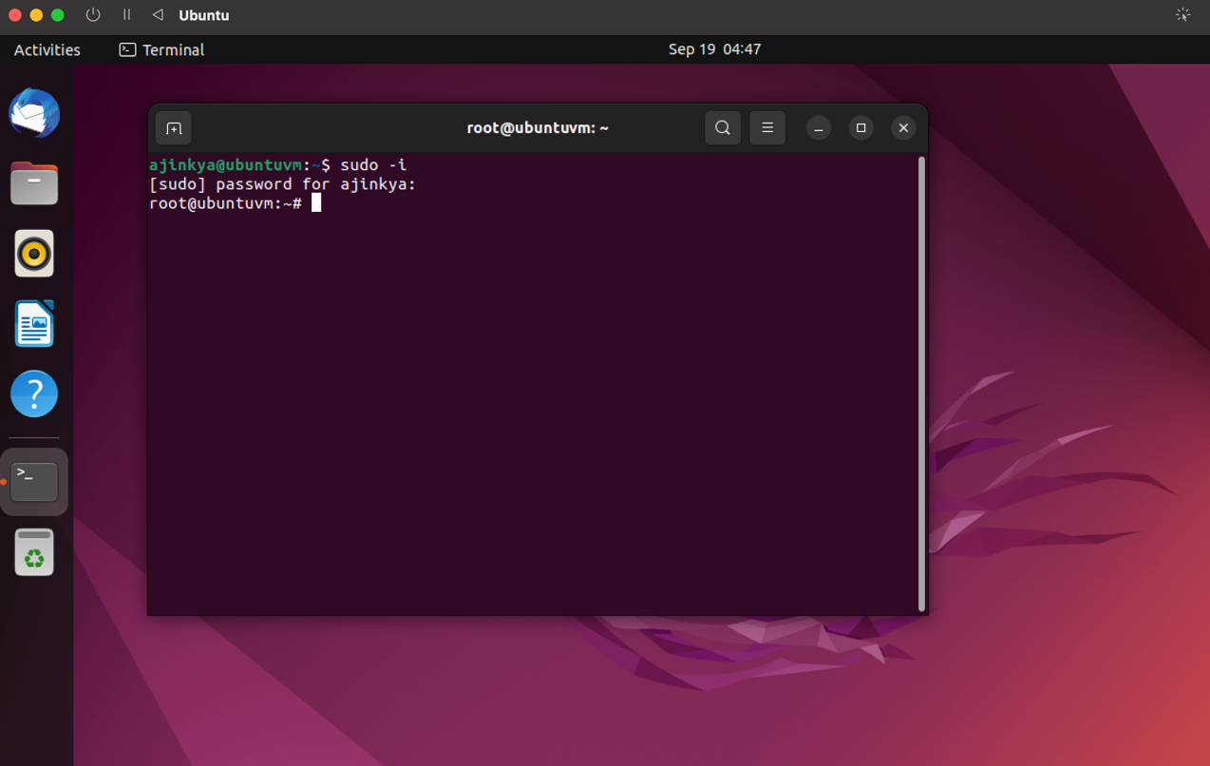

**Part 2:**

**Answer 1: Commands**

Below are screenshots of all commands in the assignment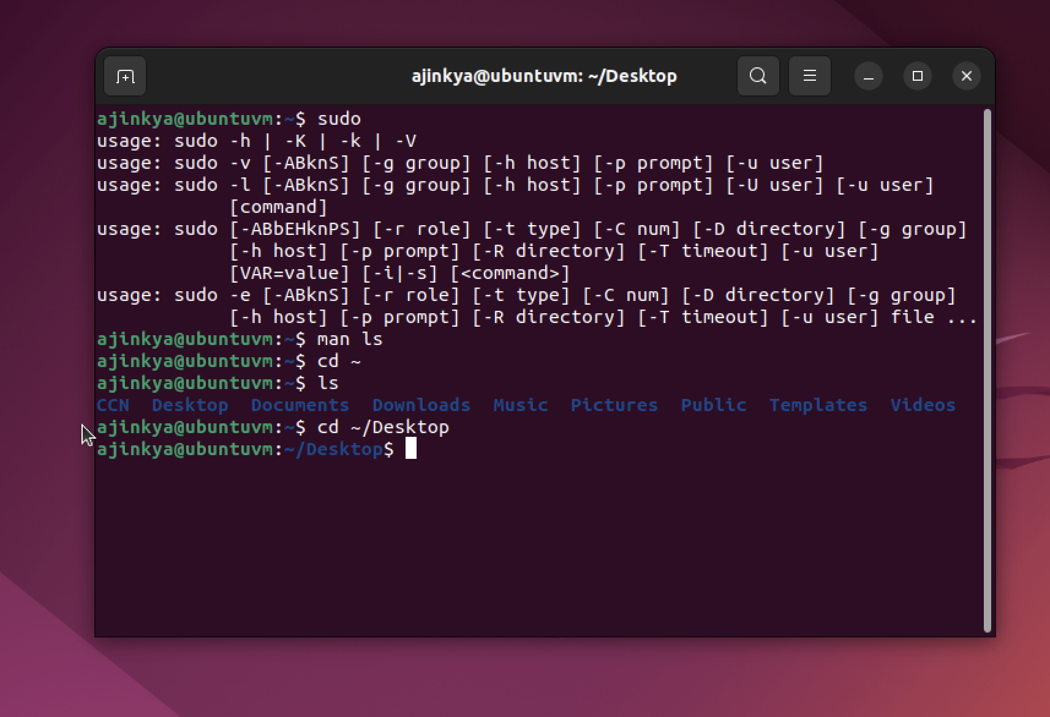

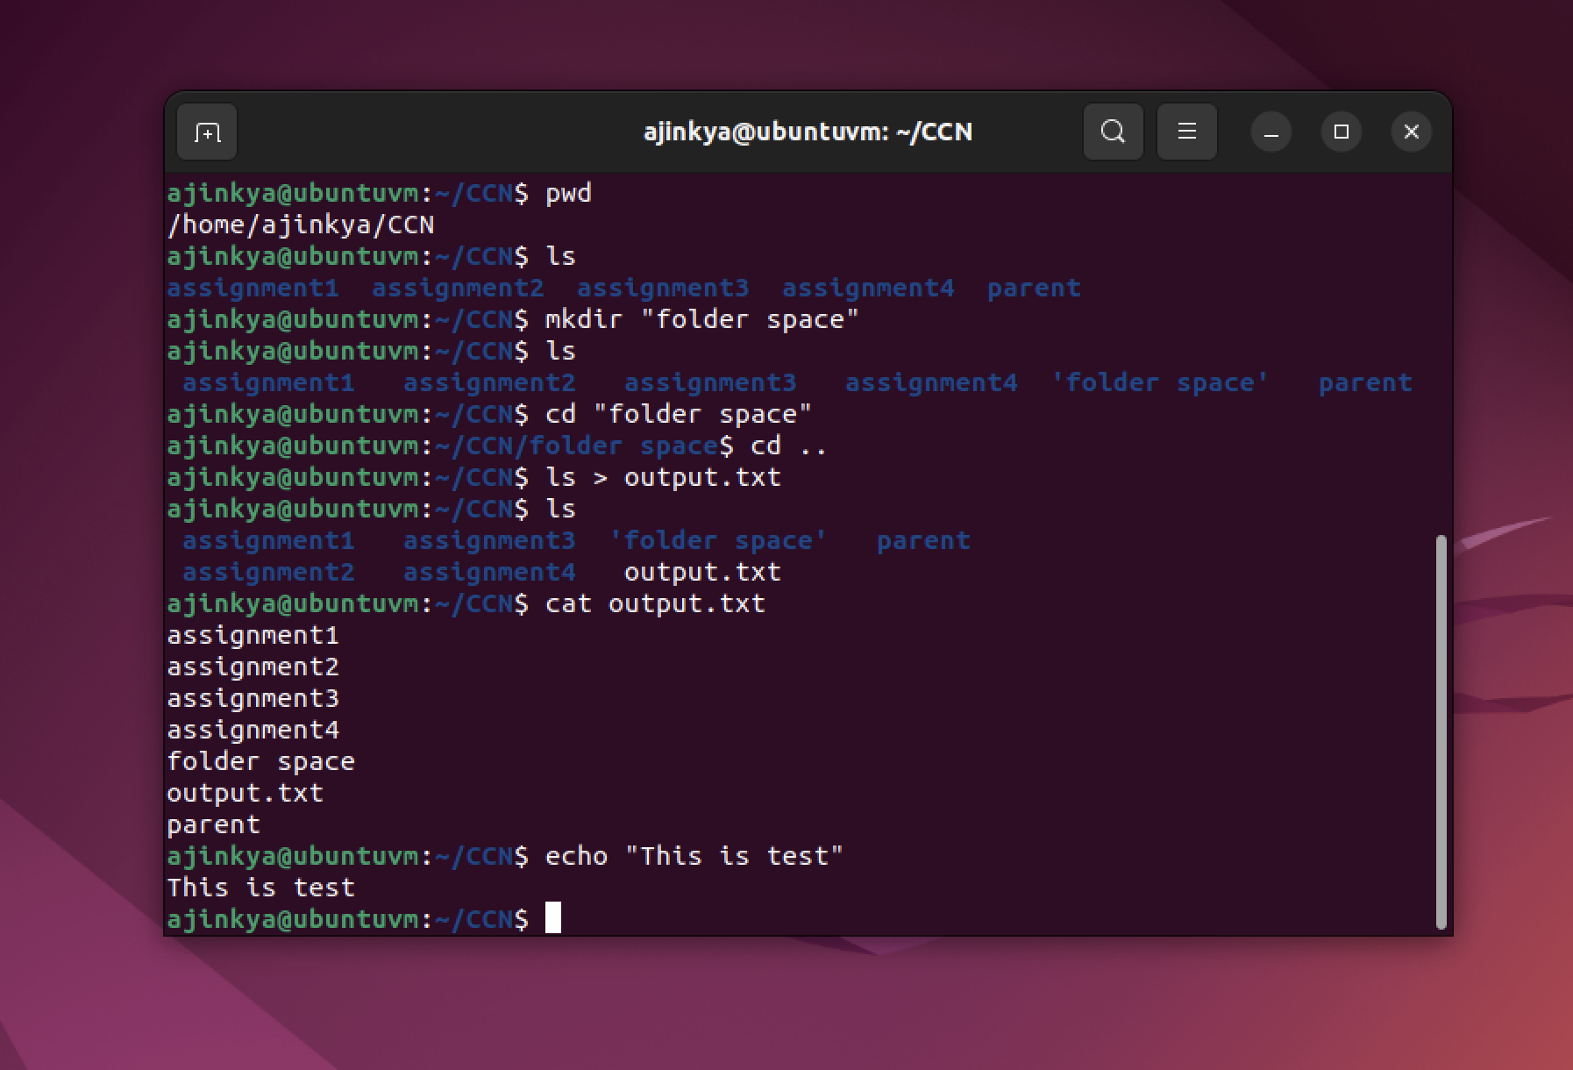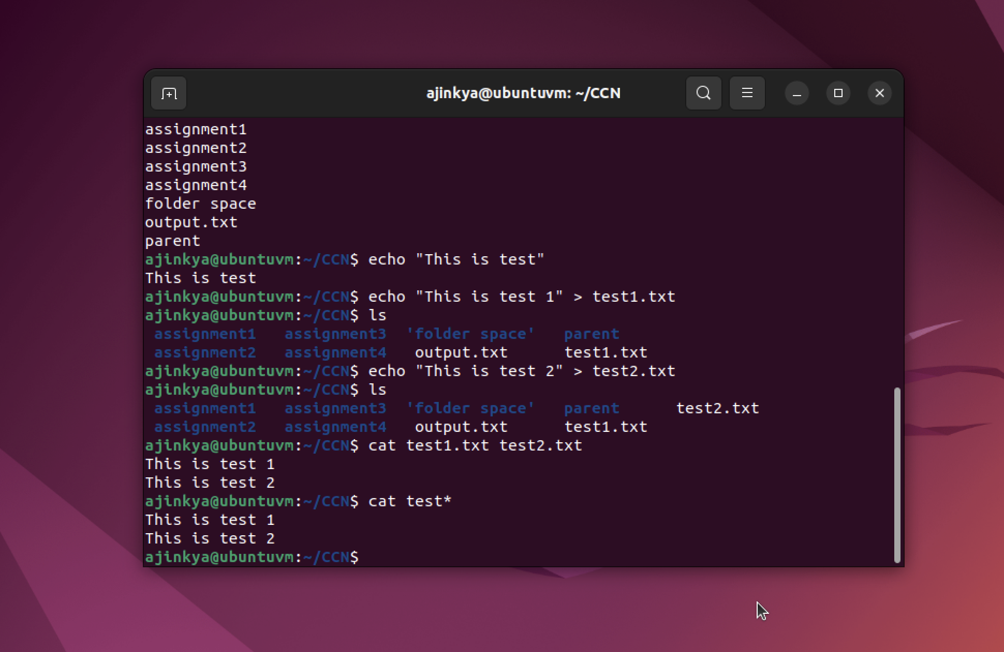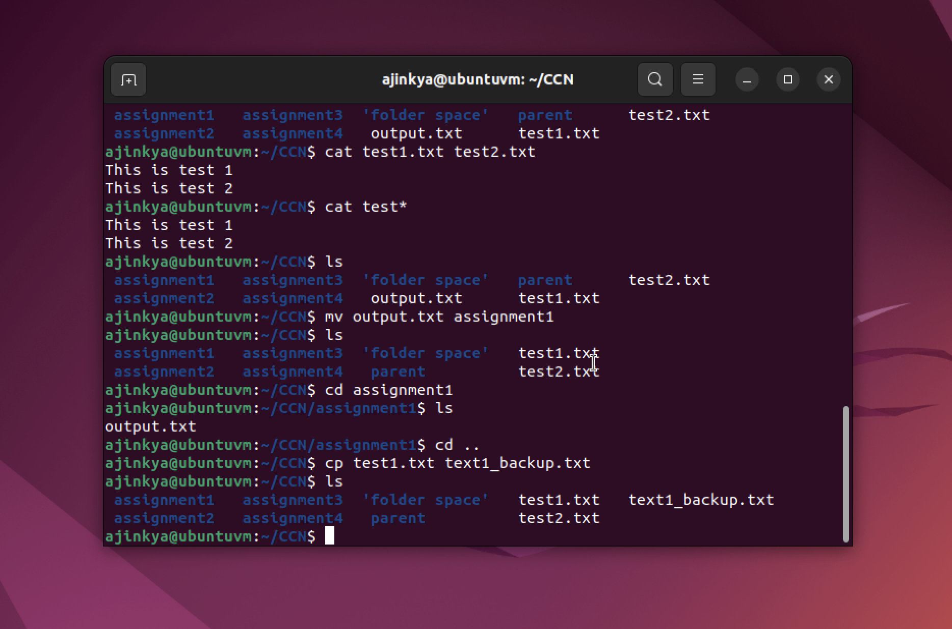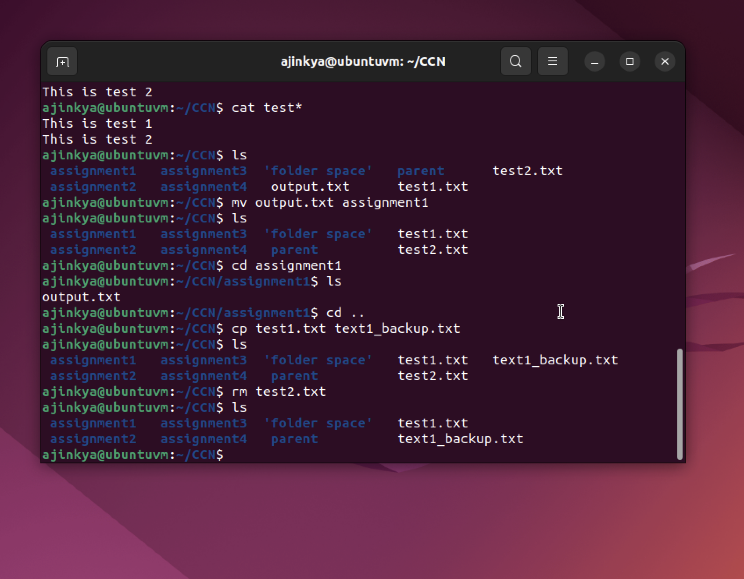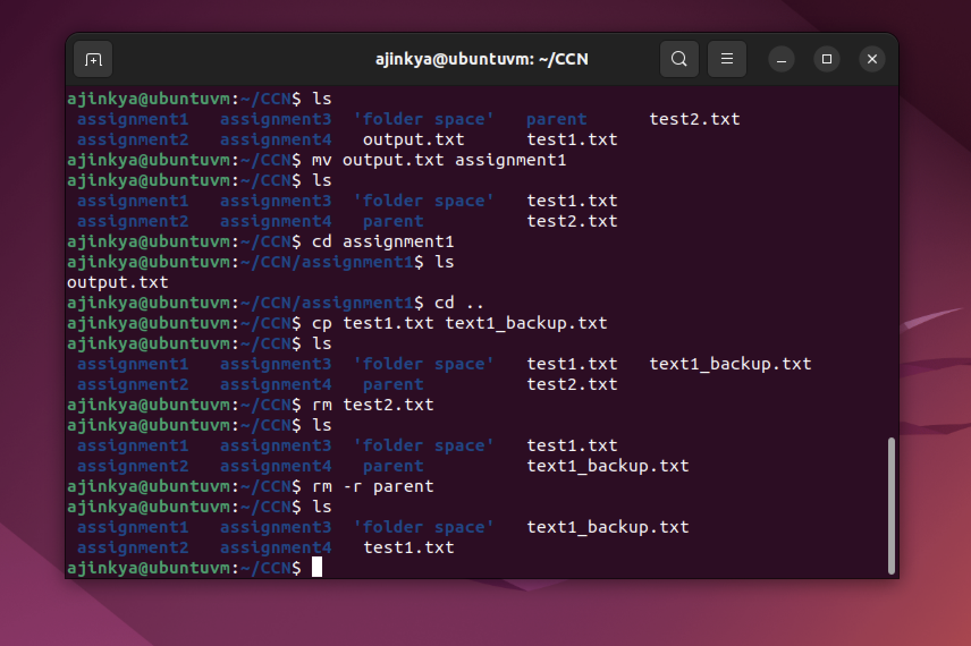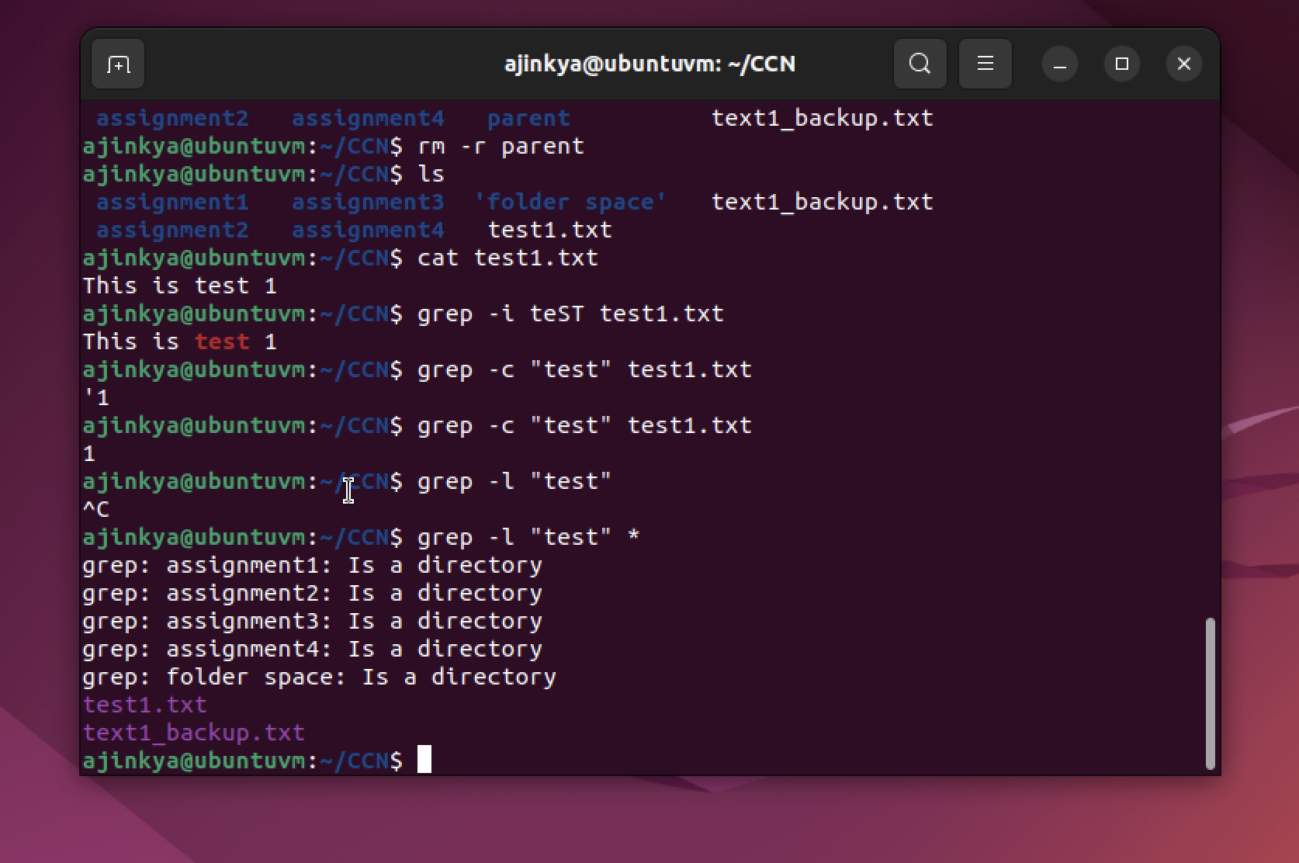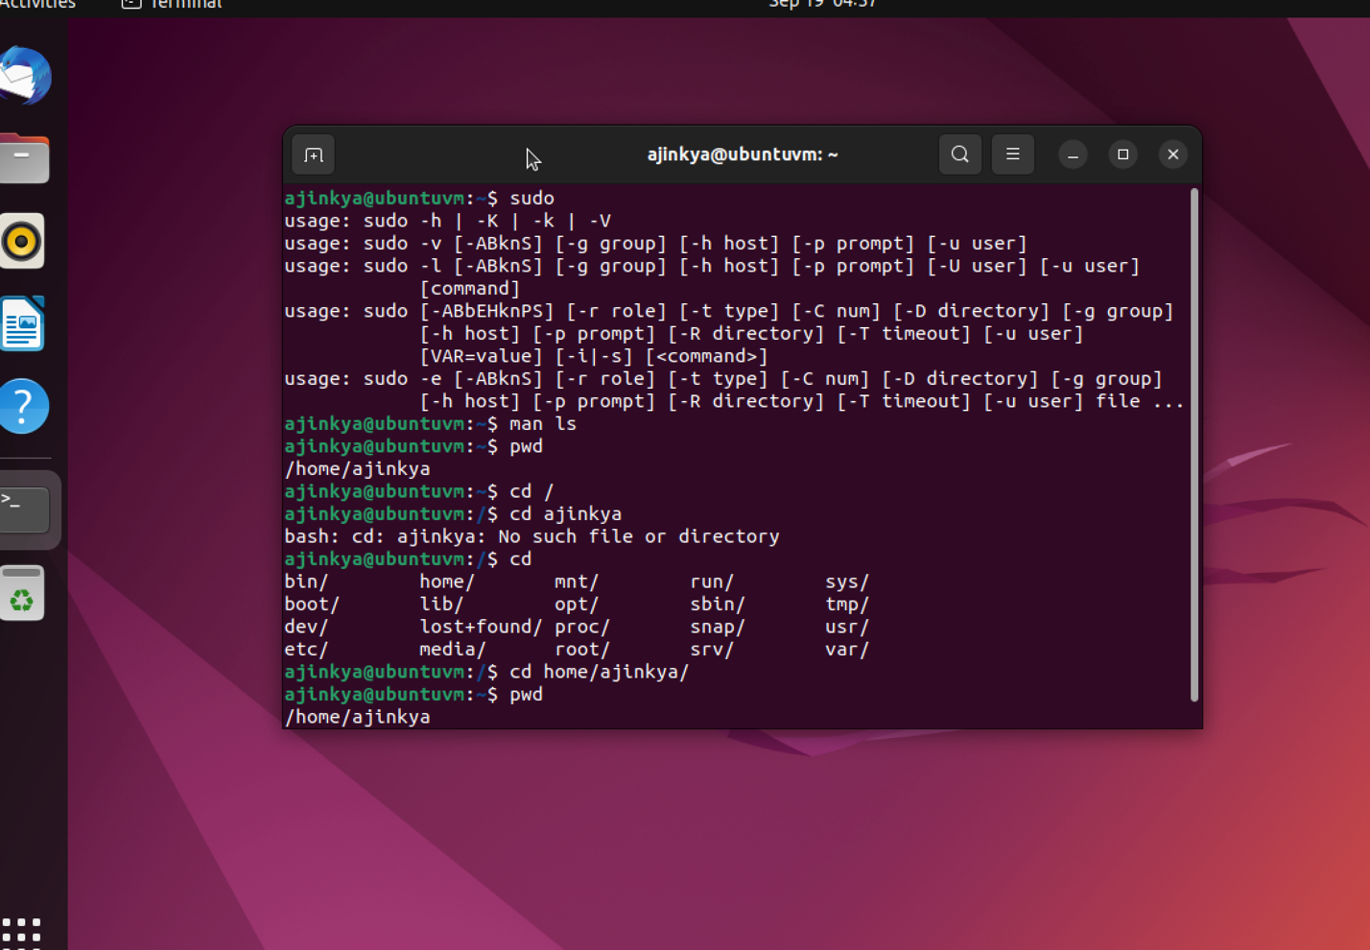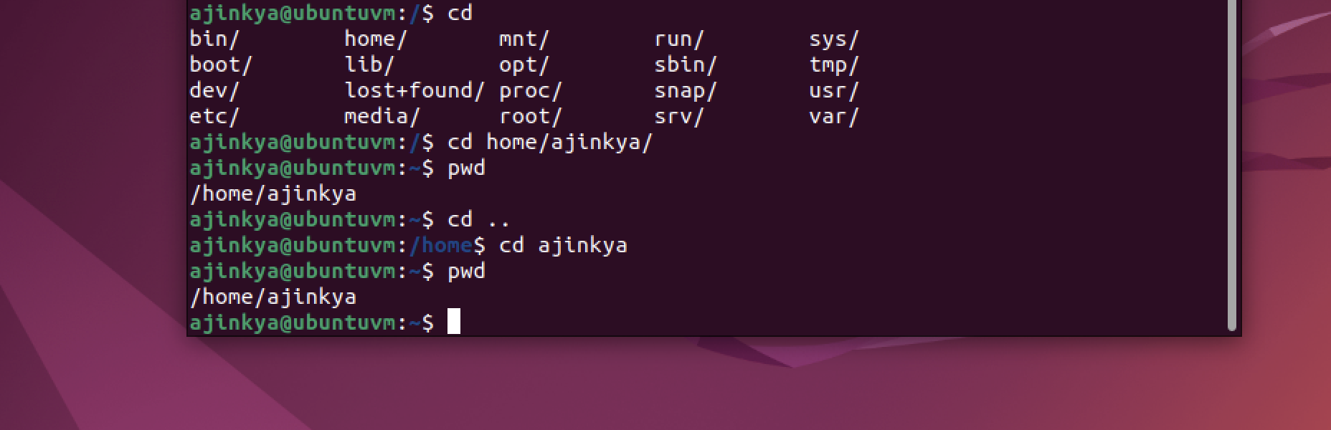

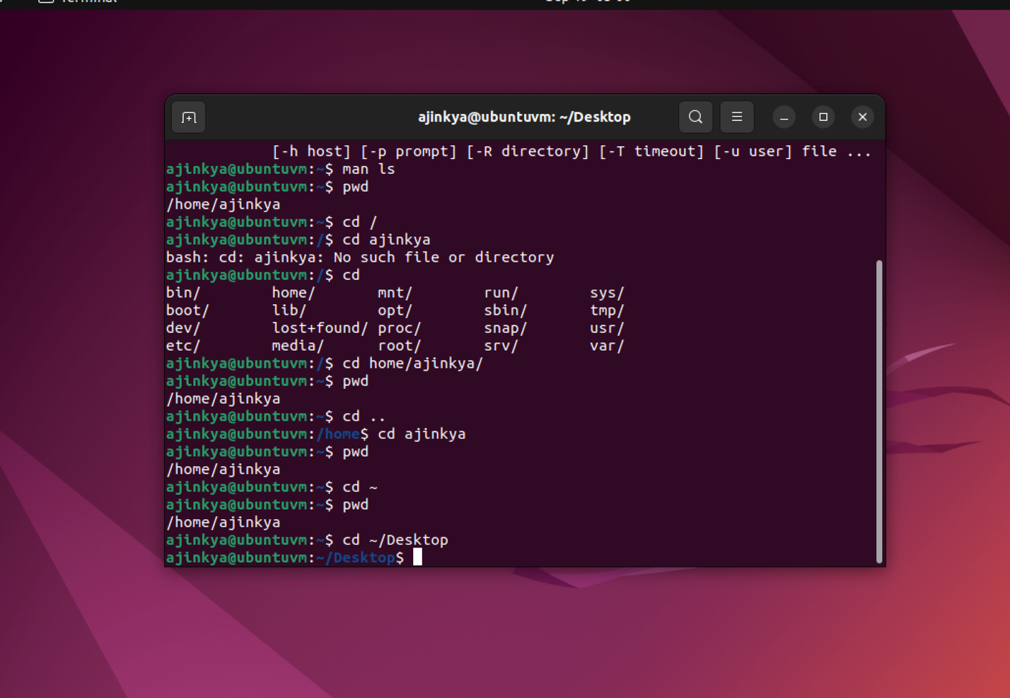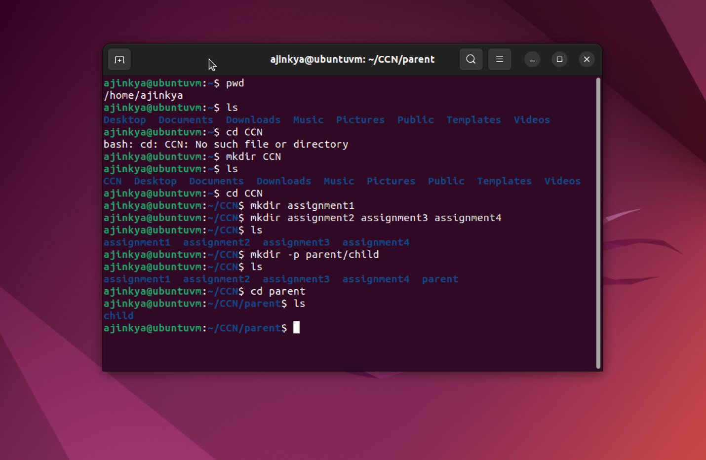

**Answer 2: Python program for hello world**

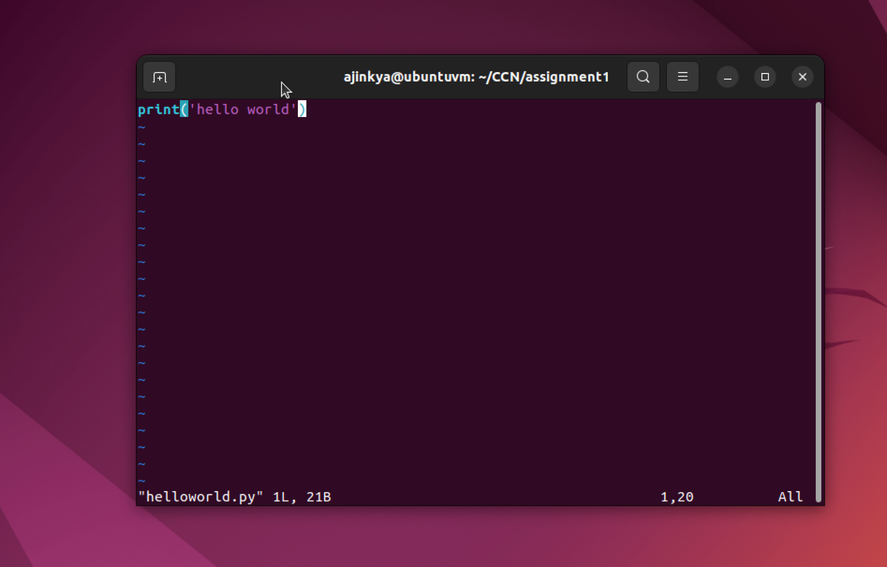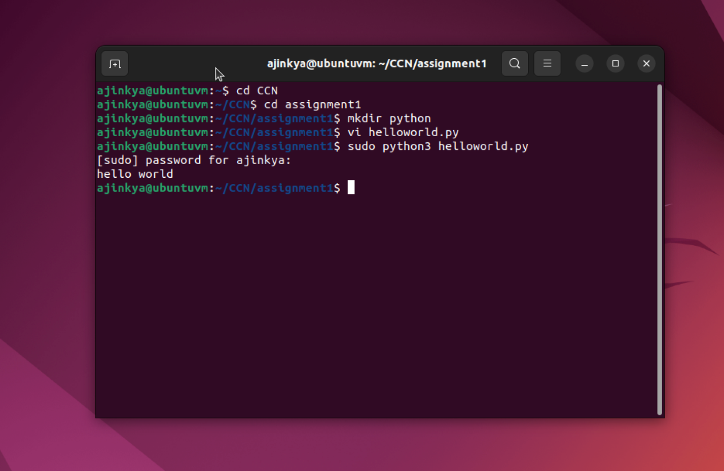

**Answer 3: Vote program**

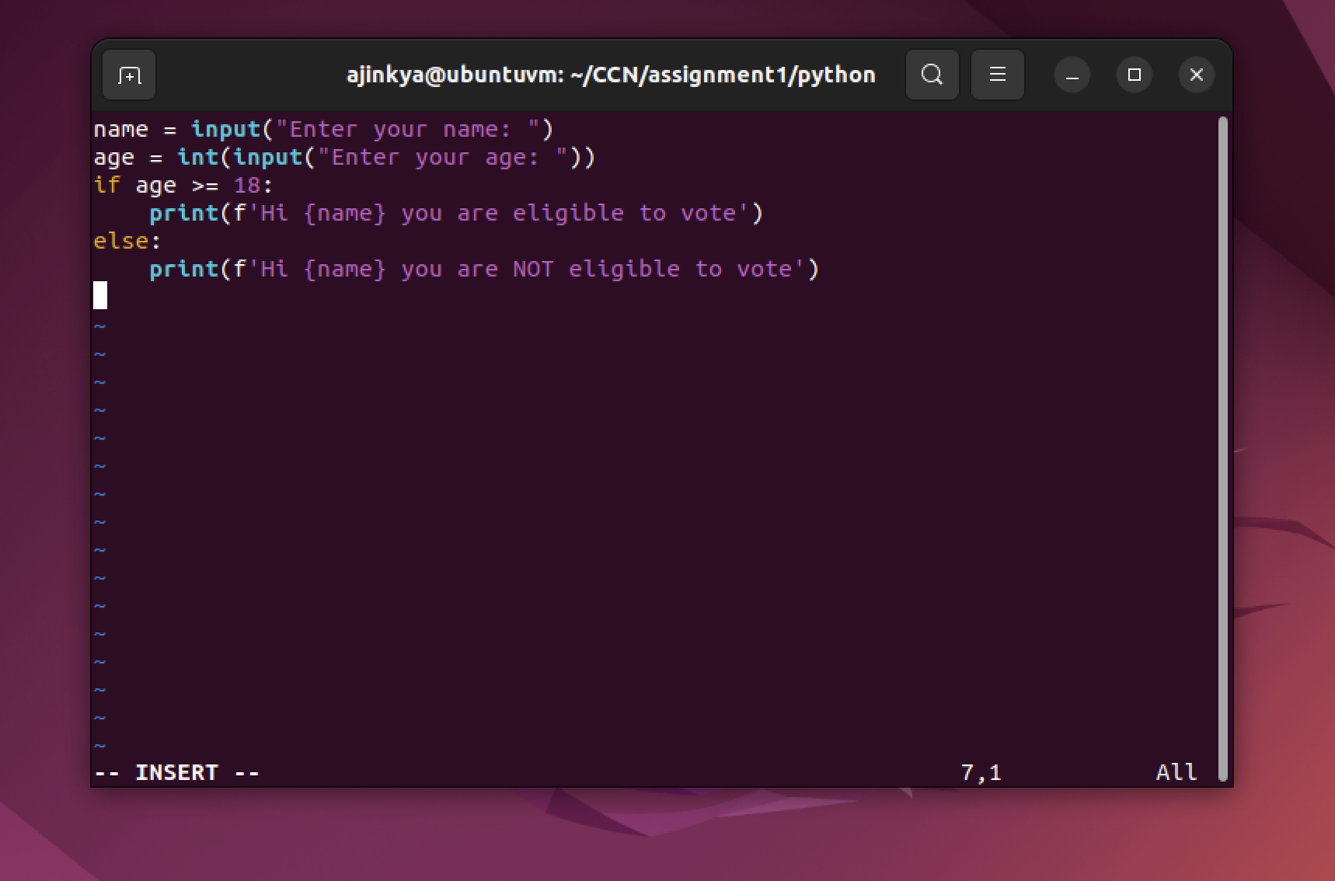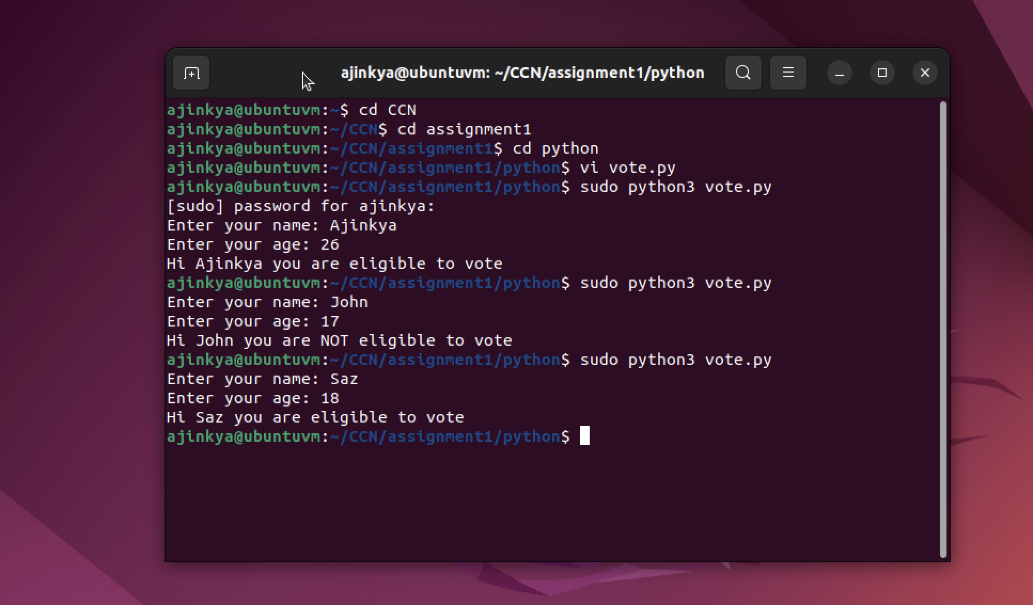

**Answer 4: Bandwidth code**

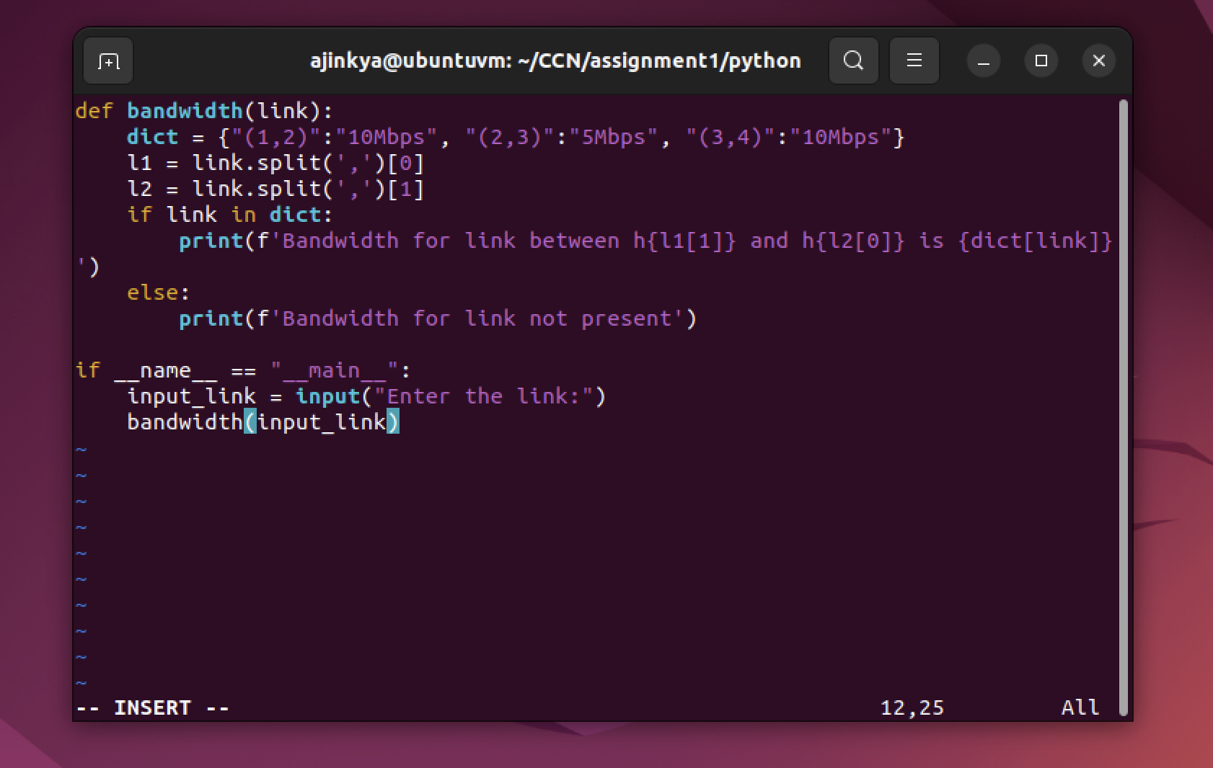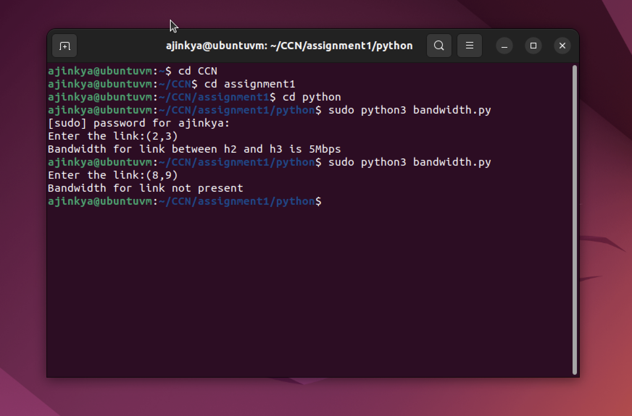

**Answer 5: String reverse using decorator**

